1.     Rank employees by their total sales

(Total sales = Total no of orders handled, JOIN employees and orders table)

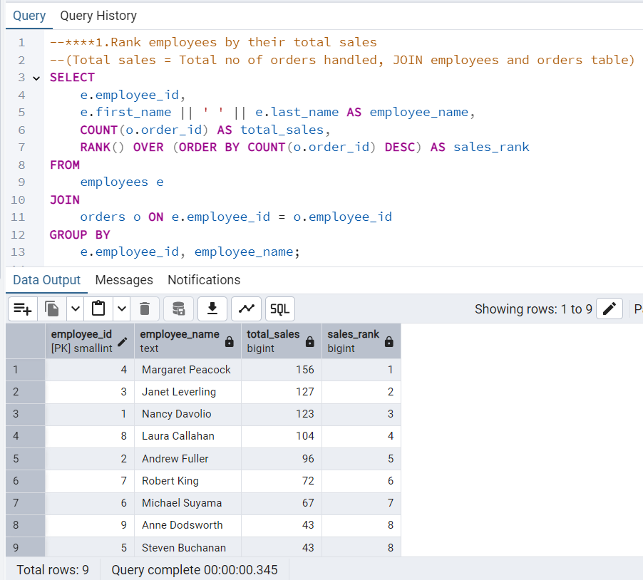

2.      Compare current order's freight with previous and next order for each customer.

(Display order_id,  customer_id,  order_date,  freight,

Use lead(freight) and lag(freight).

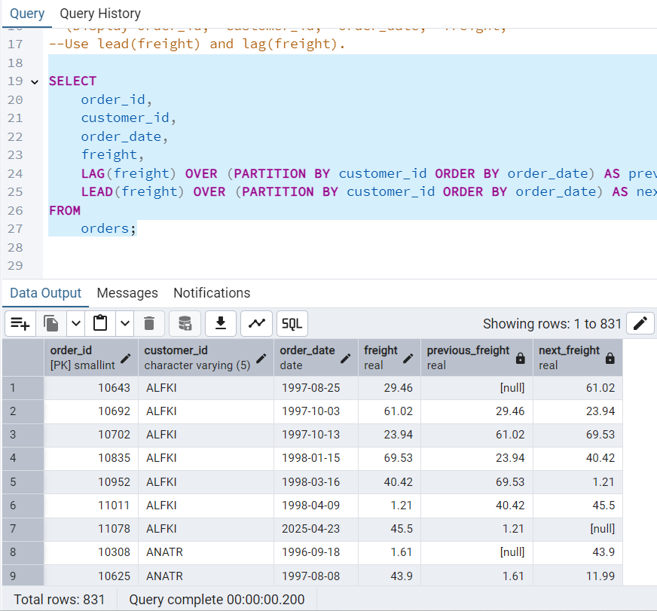

 3.     Show products and their price categories, product count in each category, avg price:

         (HINT:

·  Create a CTE which should have price_category definition:

         WHEN unit_price < 20 THEN 'Low Price'

            WHEN unit_price < 50 THEN 'Medium Price'

            ELSE 'High Price'

·  In the main query display: price_category,  product_count in each price_category,  ROUND(AVG(unit_price)::numeric, 2) as avg_price)

